"End Of Season Run 2016"
‘Autumnal Perthshire’

REPORT

30th October 2016

The last car event of 2016 of The Scottish Vintage Austin Enthusiasts Club saw around 23 cars, of which around 16 were classic/vintage cars and the rest being moderns, gather at the central location of Dobbie’s Garden Centre in Perth. Brilliant sunshine and a decent temperature was supplied by organisers Alex and Wilma Fender and Paddy McDermott, thanks guys! This brought smiles to all attendees who looked forward to a social day of vintage motoring. A £5 per car was collected and a total; of £120 was collected for The Scottish Air Ambulance
After the compulsory catch up chat in the coffee shop (and the men were all around admiring the cars!) it was off north and west. The date this year had been delayed in order to enjoy the autumnal colours in this beautiful Perthshire area.
The 54-mile route certainly went as planned with scenic after scenic photos were taken as we passed through tunnels of glorious light brown/yellow and green trees and hedges, that worked perfectly, well done the organisers.
The route was over the smallest ‘B’ roads and I suspect a lot of unclassified ‘C’ roads as well, the passing places were well used! We headed for Luncarty, Blargowrie, Meikleour and Stanley with warning signs for ‘Red Squirrels’ was noted but we never saw any! Just past Tullybelton here it was, the famous HAIR PIN BEND followed by the equally enjoyable (and now well photographed as arranged by our organisers) Ford Crossing. Nice to get the wheel washed!
A social gathering and raffle draw at the Creiff Visitor Centre where Alex, Paddy and Wilma were warmly thanked by chairman Jim Galloway for organising a fantastic finale to the season.

Here is Alex and Wilma checking out the depth, lucky for us the level was low!
More photos are on Facebook, see club website for the link.
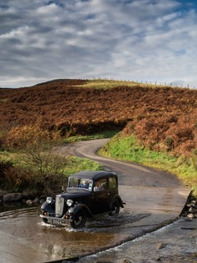

Bob Archer
http://www.scottishvintageaustinenthusiastsclub.co.uk

