"Dave Aitken Spring Run 2016"
Drive It Day
Hills – Lochs - Glens

REPORT

24th April 2016

This year saw the 14th Anniversary of this event. Yes, 14 years since our friend and very enthusiastic classic car/motorcycle member passed away.
However Dave is fondly remembered every year. Once again Judi and family chose a charity, this year being a donation to the Stroke unit in Perth Royal Infirmary for the £5 per car entry fee to go to.

This run was also planned with the National ‘Drive it Day’.

Organised exceptionally very, very well on behalf of The Scottish Vintage Austin Enthusiasts Club and The Fife Historic Vehicle Club by Ian Headrick. 12 cars of all ages and capabilities joined together at the starting point at Kinross Service Station on the M90.

The day was dry, bright and sunny if a bit chilly, but after the cars had sat in the sunshine whist social chatter and coffee perused all was well as the ‘off’ was sounded……

Ian’s ‘Hills, Lochs and Glens’ run took us south through and beyond the mono blocked streets of Kinross itself crossing the motorway passed Townhill/Dunfermline signs before heading over the hills and through Steelend and Saline. Meandering the very remote B roads saw us suddenly ‘appear from nowhere’ to the coffee stop, ‘Sterling in Tillicoutry’, magic!

The second half of the run took us on an exceptionally scenic tour of the mountainous area between Bridge of Allan and Comrie, some fantastic Scottish views from a single track road ever seen followed by an enjoyable run up the remote east side of Loch Lubnaig and down the north side of my favourite Loch, Loch Earn, to the finish point of Crieff Visitor Centre.

Following some more ‘compulsory’ refreshments Ian announced the winners in the Dave Aitken Shield. Best cars: -
1st Alan Stewart’s Bentley
2nd was Ian Headrick’s Rover P2
3rd was Bob Archers 1934 Austin Ascot 12/4

Bob Archer

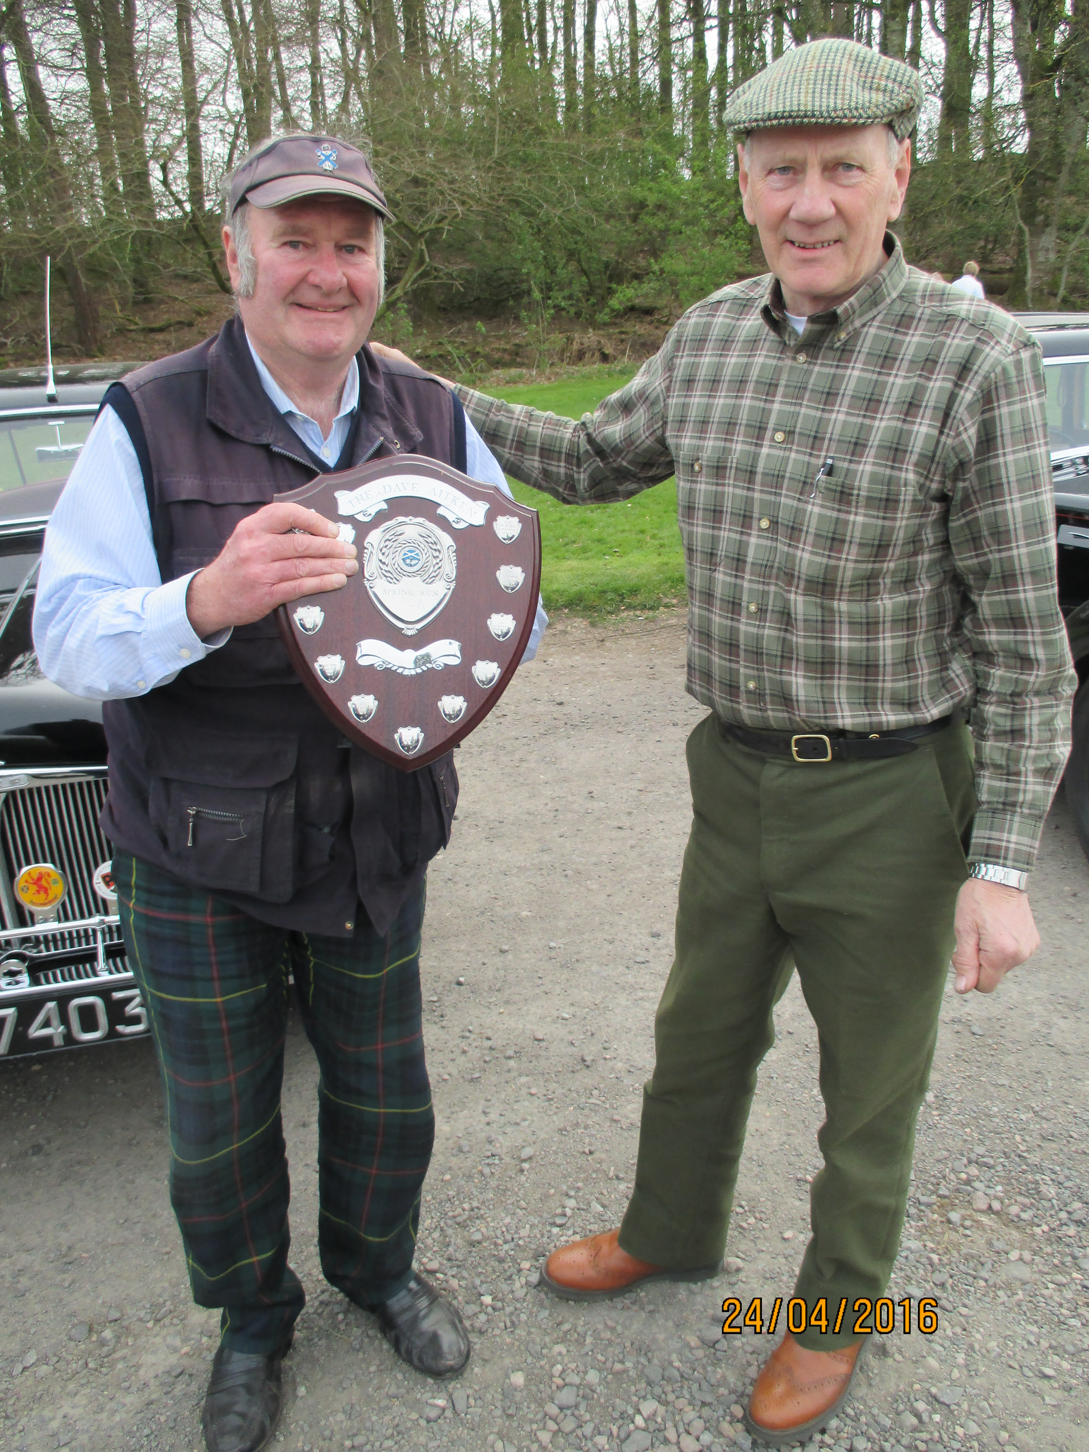

Ed – Sorry for picture format!!!!!

